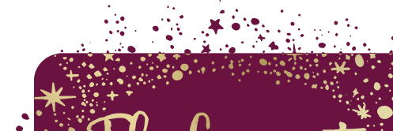

The Curiosity Approach in the EYFS at The Mary Bassett Lower School
The Curiosity Approach is a modern-day approach to early childhood education. Inspired by and bringing together aspects of many childhood theorists, this approach creates a unique offer for the children at TMBLS.
We began the journey towards our accreditation in Spring 2022 within our Nursery environment and intend on implementing this approach in the Reception classes in September 2022.

We chose to work towards this accreditation because we wanted to develop the EYFS environment to provide opportunities to capture children’s natural curiosity, awe and wonder for life and the world around them, through creating rich environments, full of open-ended resources, authentic items, and loose parts. We have begun to replace toys with open ended resources, allowing children the freedom and creativity to problem solve, use their imaginations and extend their play in any way they choose. This approach to early childhood education aims to teach children ‘how’ to think rather than ‘what’ to think.

In our Nursery we have a continuous provision which is based on the children’s individual next steps. This is available throughout the day, inside and outside to provide children opportunities to achieve and also to extend their play. This is full of purposely chosen items to inspire children, enable play opportunities, practice, and develop age appropriate skills, whilst gaining confidence, independence across the whole Early Years Foundation Stage.
We enhance the environment further by setting up ‘invitations to play and provocations’. These may introduce children to new ideas, concepts, skills, processes or resources, but are very different to ‘activities’ which have a set outcome. An invitation or provocation although set up with an ‘intention’ is open ended and can be accessed and played with in any way the child chooses.
Although we have only be using this approach for a few months, we have already seen a noticeable increase in pupil interactions. Pupil engagement has increased and the emphasis on PSED and C&L has resulted in collaborative working between both children and practitioners. Practitioner interactions have strengthened and the link between the developmental level of the child, their next steps and the provision is strong. Staff have demonstrated a good understanding of the needs of their key children and adapt the provision to ensure these needs are met.
The next stage of the process is to continue to develop the outside provision in Nursery and to build the learning journey cycle. In Reception, the next stage is to develop the environment and the use of ‘invitations to learning’ to embed the taught offer and to also ensure next steps for children are met.

